  - High-Precision Modular Loop Current Driver and Receiver
  - Demo Manual

Contents
Summary 2
Sales Pitch 2
Packaging & Set Up & Tear Down 3
Running the Demo 7
Technical Background 9
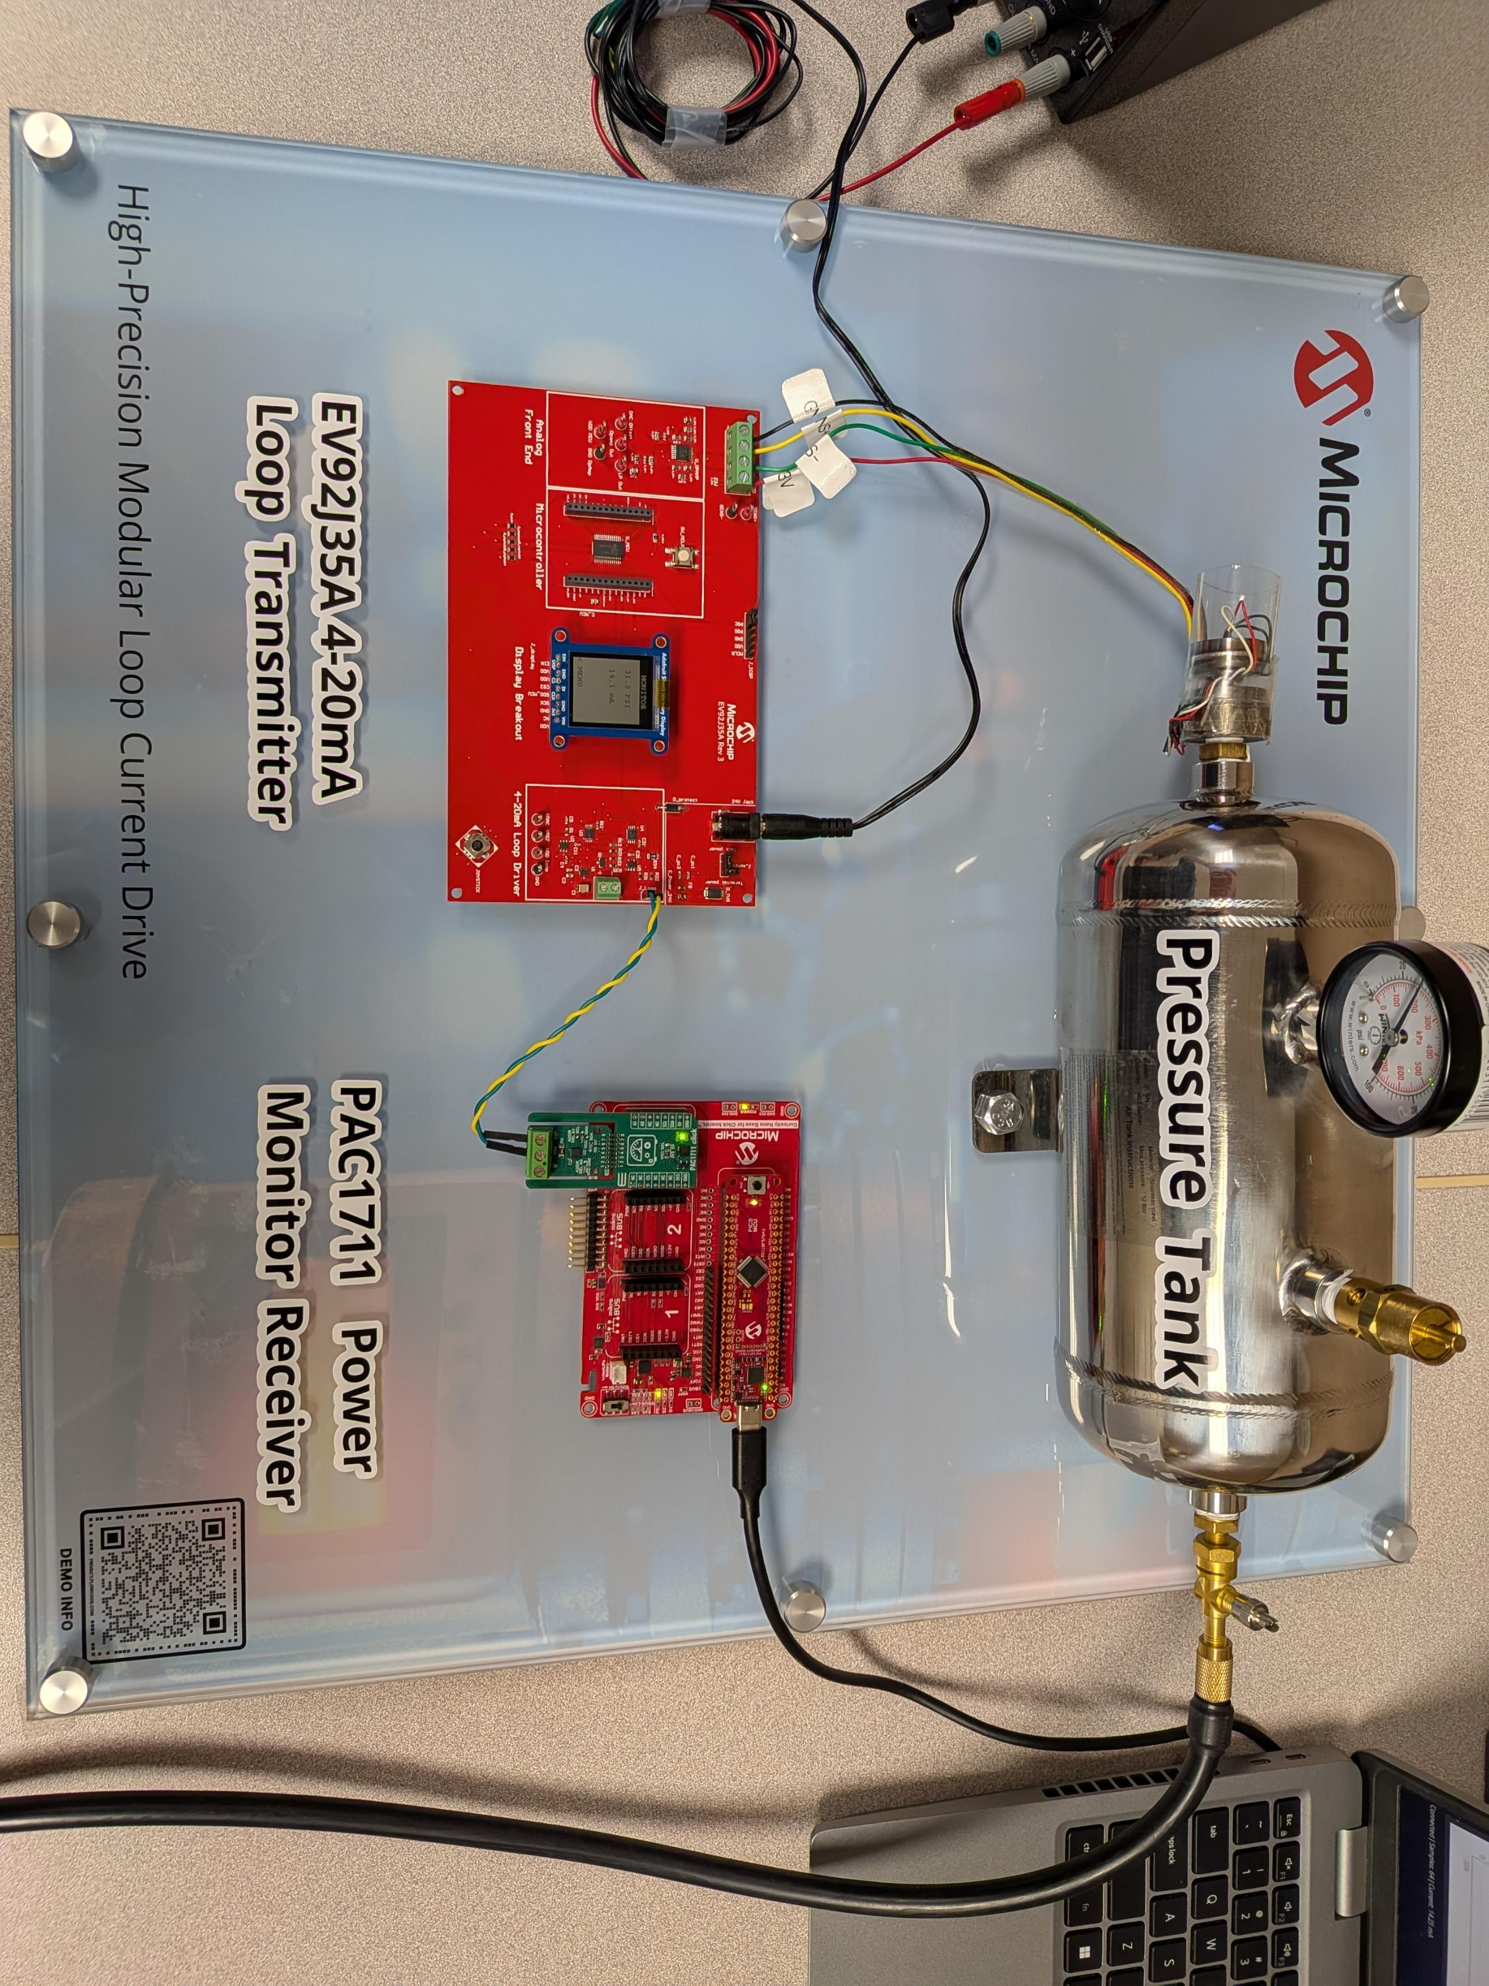

Summary

Description:
The demo (DU2457) showcases an integrated industrial signal-conditioning solution that converts a differential pressure-sensor signal into a standards-based 4–20 mA current-loop output. The updated design combines the 4–20 mA DAC-based reference design and the differential signal-conditioning circuitry on a single board, creating a compact and flexible platform for industrial sensing and process-control applications.
The demonstration features:
- A differential analog front end for conditioning sensor outputs
- Analog filtering to reduce noise and improve signal integrity
- Digital calibration and trimming using a digital potentiometer
- SPI communication for configuration and control
- A 4–20 mA loop driver for interfacing with industrial equipment
- A PAC1711 power monitor connected directly in the loop to sense the loop current and act as the system receiver using the PIC18F56Q43 Curiosity Nano development board
- An optional display for convenient monitoring of system operation
The PAC1711 enables the receiver side of the demonstration to monitor the current flowing through the 4–20 mA loop. The PIC18F56Q43 processes the measured data and communicates with the receiver GUI over UART, allowing users to view both the loop-current and pressure values in real time.
DU2457 demonstrates how Microchip Technology’s ready-made industrial solutions can be integrated to create accurate, adaptable, and practical sensor-interface systems. Although the demonstration is based on a pressure sensor, the architecture can be adapted to support a wide range of modern differential-output sensors.

Sales Pitch
The DU2457 Pressure Sensor with 4–20 mA Loop demo showcases how Microchip products can simplify the development of industrial signaling systems. By integrating the 4–20 mA DAC-based reference design with the differential signal-conditioning circuitry on a single board, this solution provides a flexible platform for connecting today’s sensors to established industrial control infrastructure.
The demonstrated pressure-sensor application is one example of a versatile architecture that can interface virtually with any sensor with a differential output to systems that rely on the industry-standard 4–20 mA communication scheme. The design can be readily adapted for other sensor types and used as a building block for process control, factory automation, instrumentation, and industrial monitoring applications.
Microchip’s 4–20 mA loop-driver reference design delivers a maximum error of only 0.15%, including temperature effects. This accuracy helps maintain reliable sensor transmission over long cable runs and supports consistent system performance in demanding industrial environments.
The analog front end highlights the advantages of Microchip’s MCP6V1x family of zero-drift amplifiers. Their low-power operation enables them to be powered directly from the signal-loop current rather than requiring a dedicated power supply, helping simplify the overall system architecture. The amplifiers are also optimized for low-noise operation, with practically zero 1/f noise, strong power-supply rejection ratio (PSRR), and strong common-mode rejection ratio (CMRR). These characteristics reduce the need for complex active-filtering or digital-filtering techniques while helping preserve signal accuracy.
The demonstration has also been enhanced with a PAC1711 power monitor connected in the 4–20 mA loop. The PAC1711 senses the loop current and represents the receiver side of the system, demonstrating how the transmitted current can be monitored at the receiving end of an industrial signal loop.
The PAC1711 Click board is connected to a PIC18F56Q43 Curiosity Nano development board. The microcontroller communicates with a graphical user interface over UART, enabling users to view the measured loop current and corresponding pressure value. This provides a clear, real-time representation of the complete signal chain—from differential pressure sensing, through signal conditioning and 4–20 mA transmission, to current measurement and system monitoring.
DU2457 provides a practical example of how Microchip’s analog, mixed-signal, power-monitoring, and microcontroller solutions can work together to bridge modern sensor technology and legacy 4–20 mA industrial systems.

Packaging & Set Up & Tear Down

Pack List:
- Pelican case
Qty | Item
2 | EV92J35A - Differential Signal Conditioning and 4-20 mA Loop Controller Board
2 | EV34C35A - DAC-Based 4-20 mA Current Loop
2 | Pressure tanks with P571 strain measurements sensors
1 | Foot pedal pump
2 | PAC1711 click boards
1 | CURIOSITY NANO BASE FOR CLICK BOARDS™
1 | PIC18F56Q43 Curiosity Nano boards
2 | Wall power supplies
4 | Jumper wires, male-to-female
4 | Jumper wires, male-to-male
1 | Acrylic Display Board
 | Zip ties
 | Bolts, washers, nuts (2 of each)

- Other equipment (source locally)
Qty | Item
2 | Adafruit SHARP Memory Display Breakout
1 | Bench power supply
1 | MPLAB® PICkit® 5 In-Circuit Debugger
1 | USB-C to USB-C cable
1 | USB-A to USB-C cable
1 | Screwdriver (for securing wires in terminal blocks)
1 | Scissors
1 | Multimeter with alligator cables

Pelican Case Packing/Unpacking:
First Layer when opening the Pelican case (Top layer):
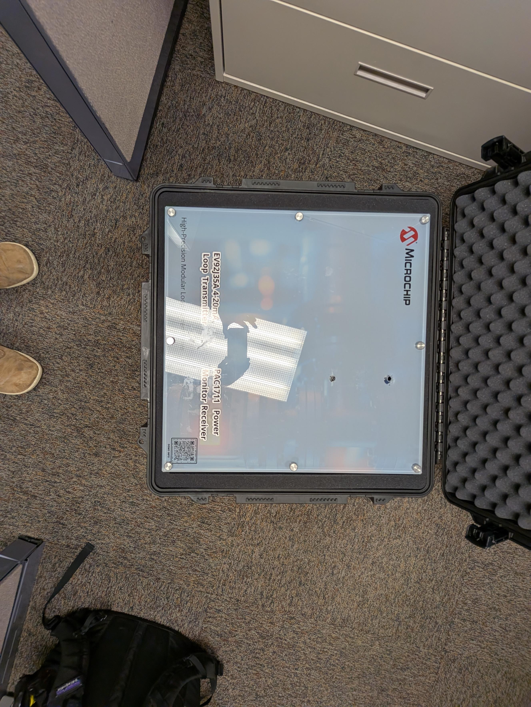
Second layer from the top:
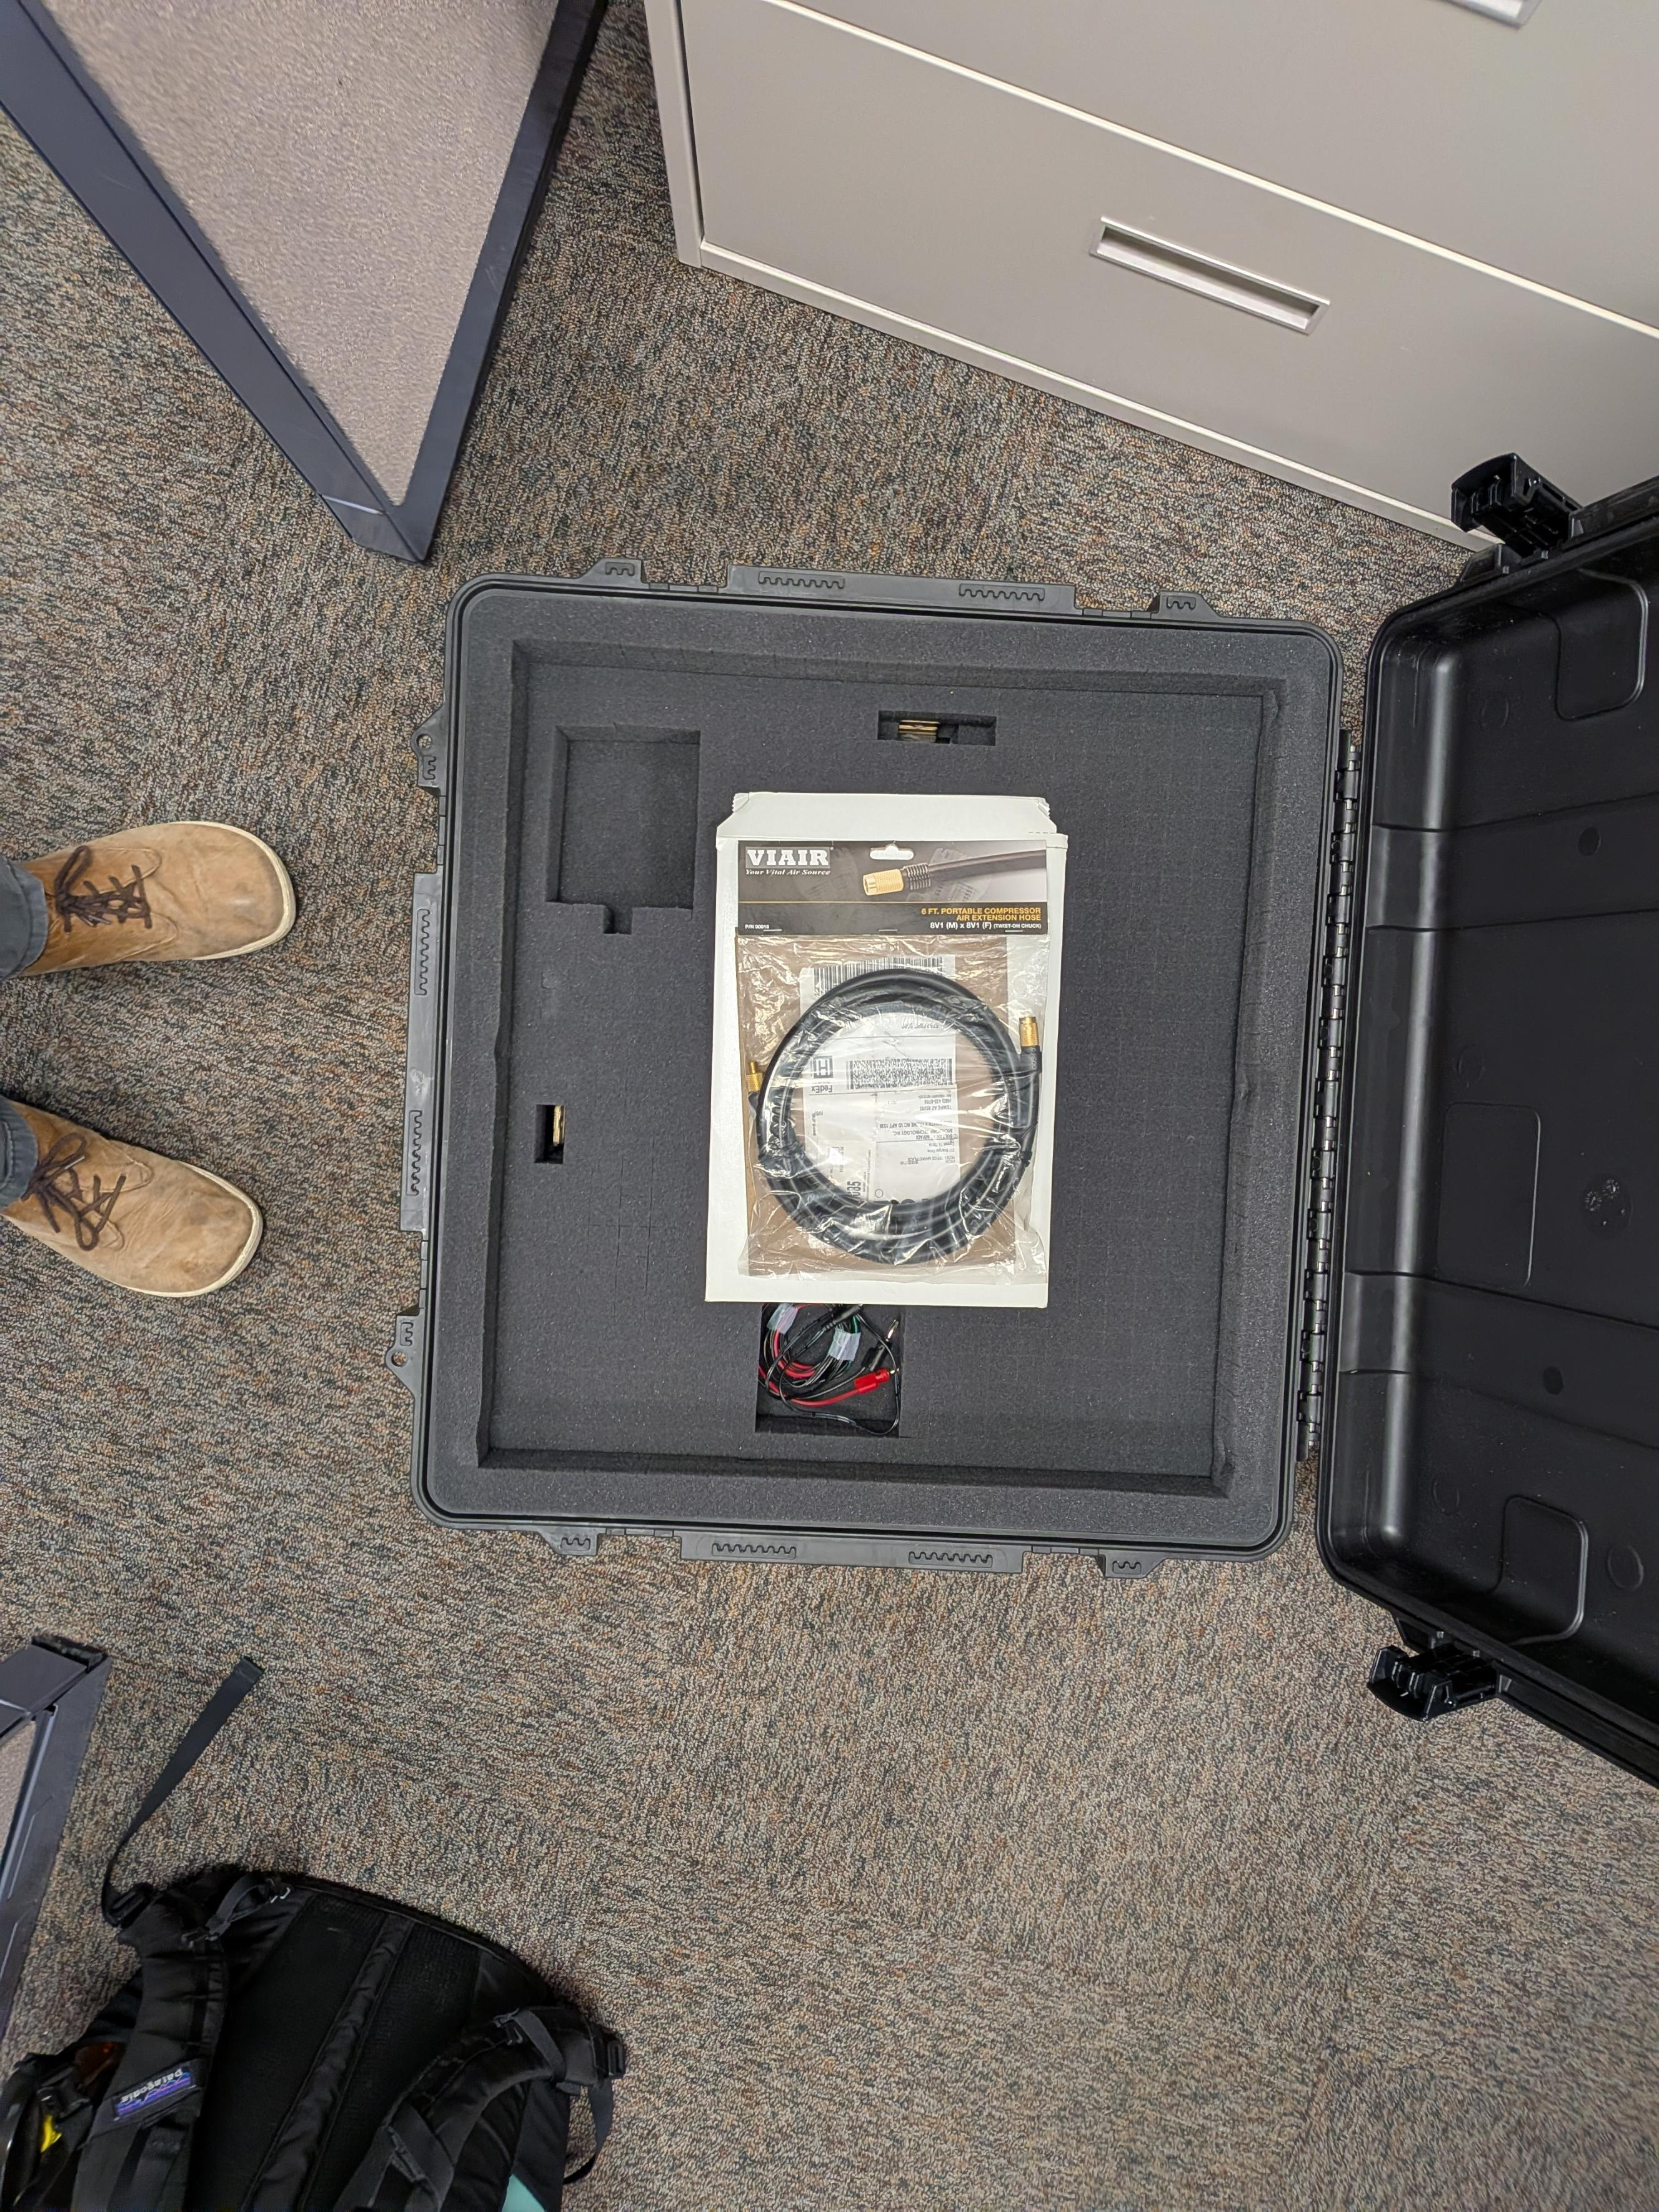
Third layer from the top:
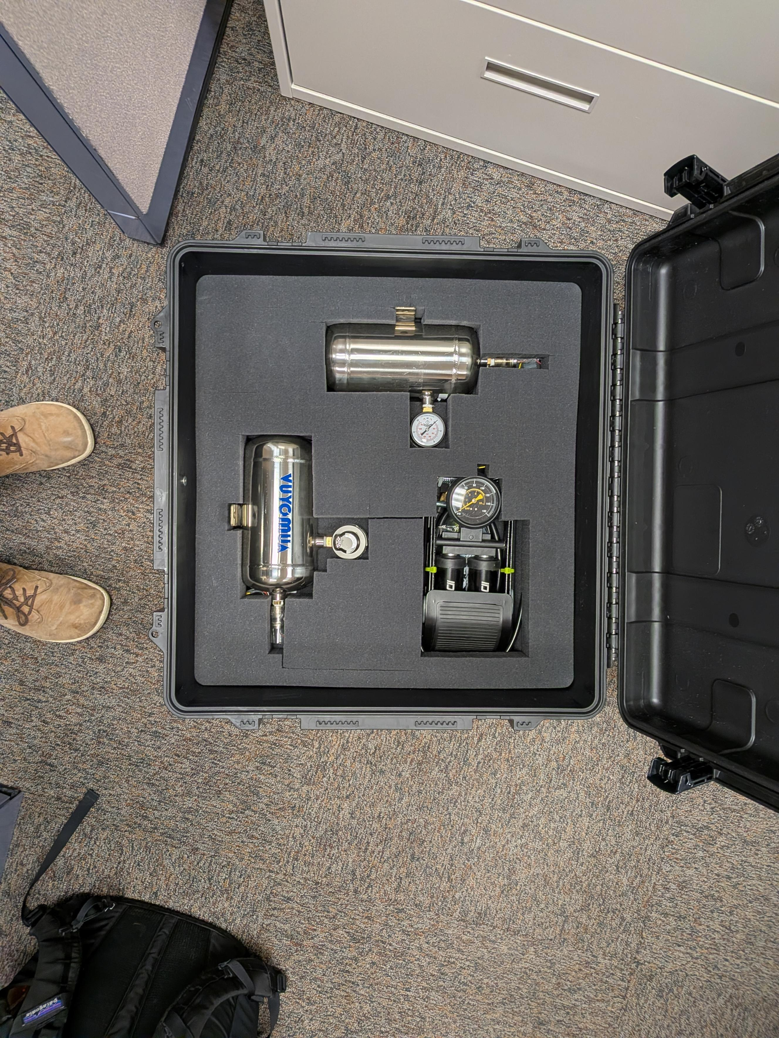
Fourth layer from the top
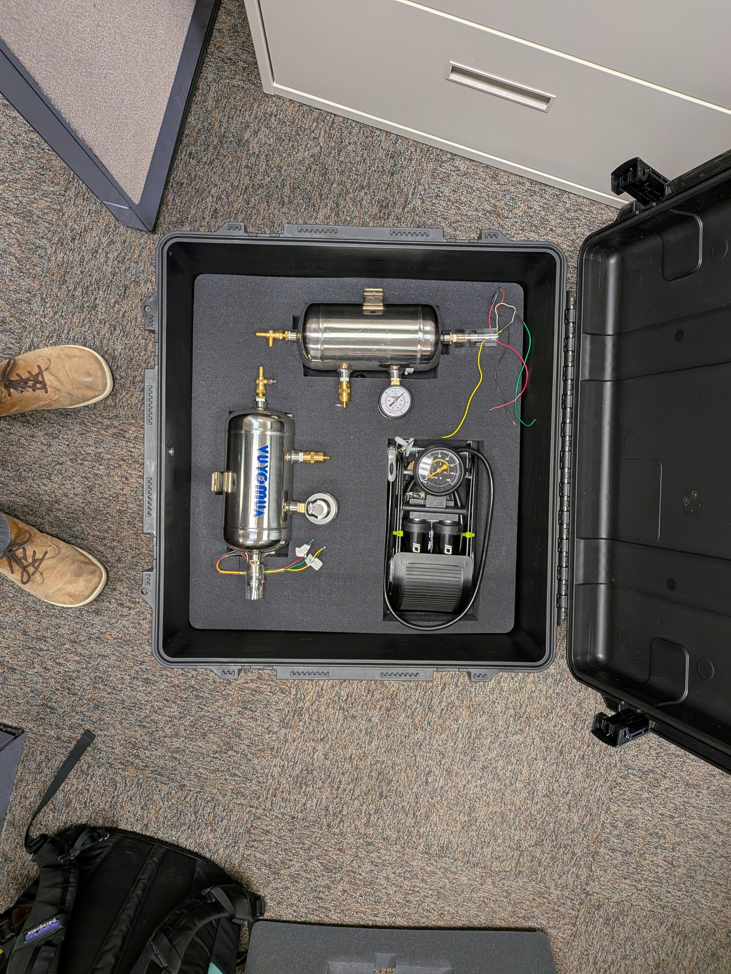

Fifth layer from the top (Bottom layer):
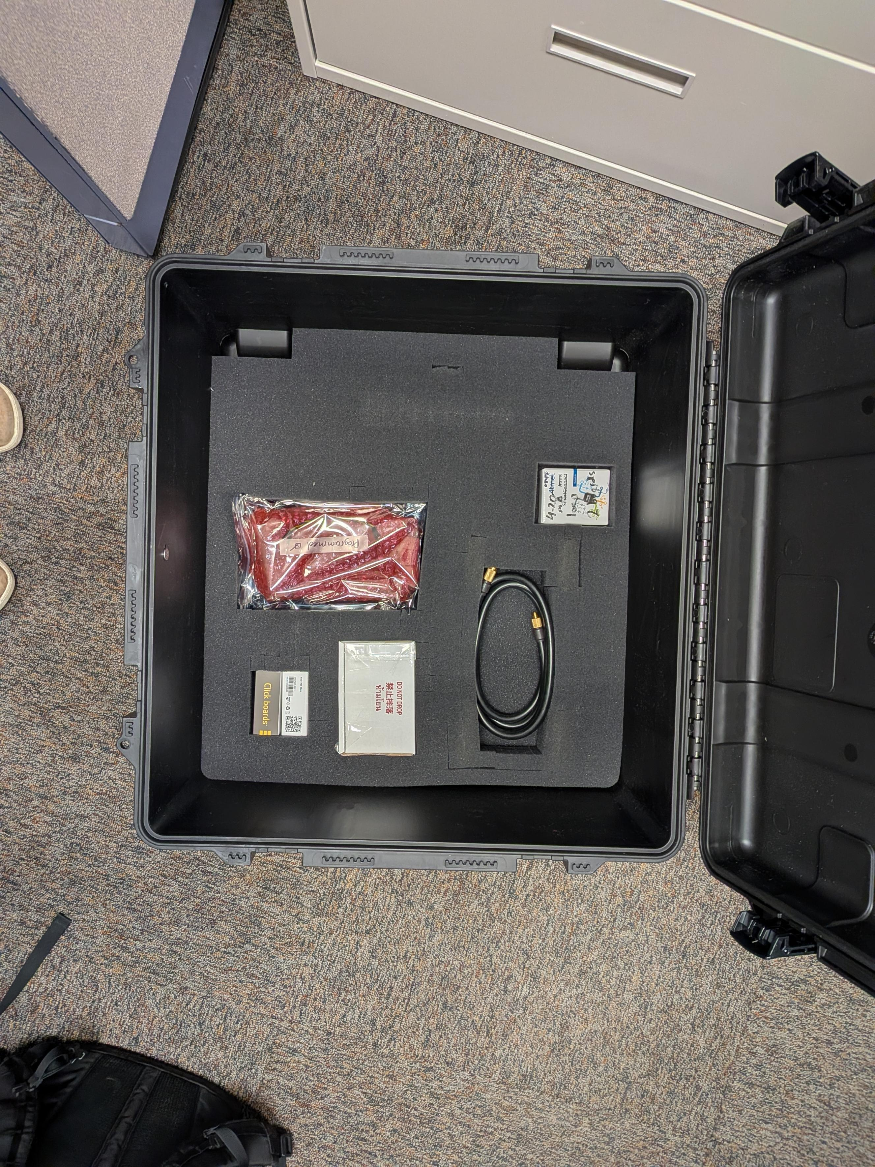

Complete Setup:

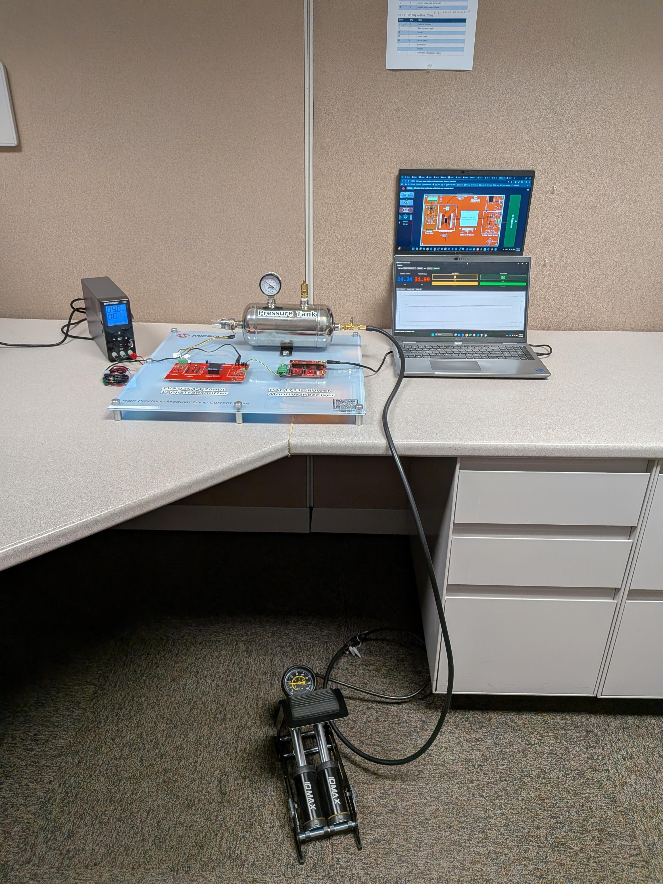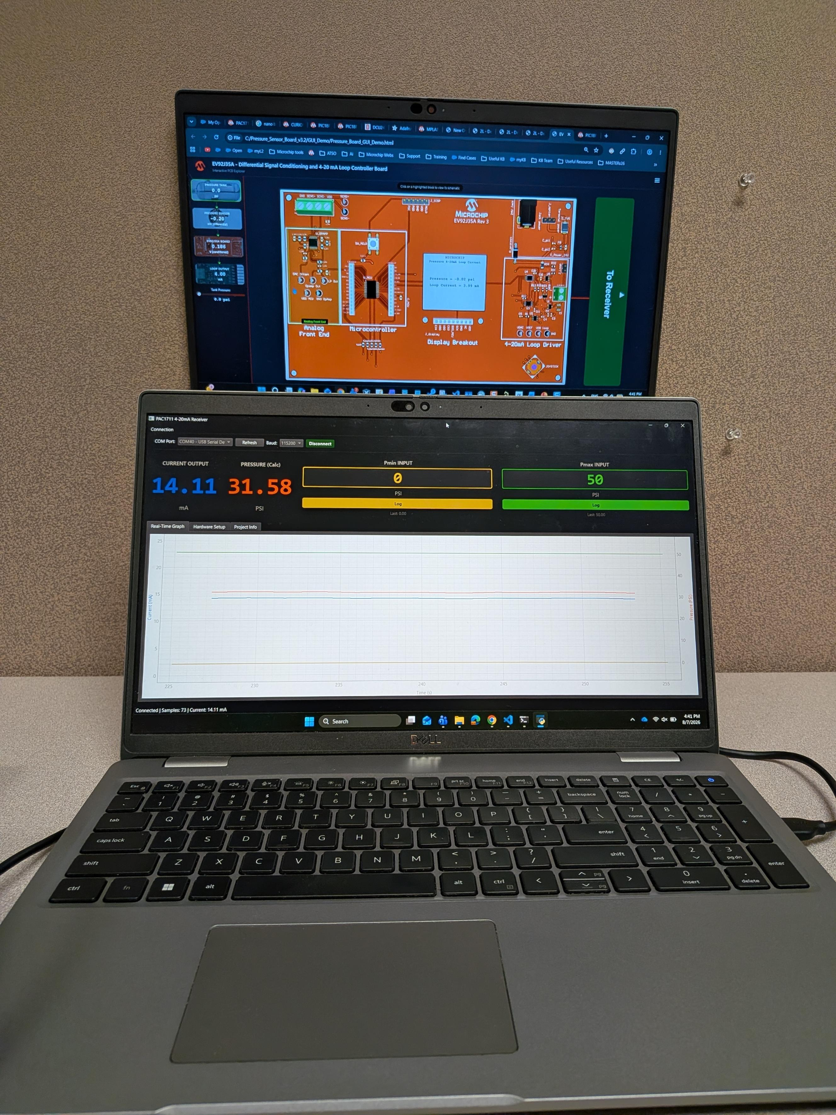

At US MASTERs 26:
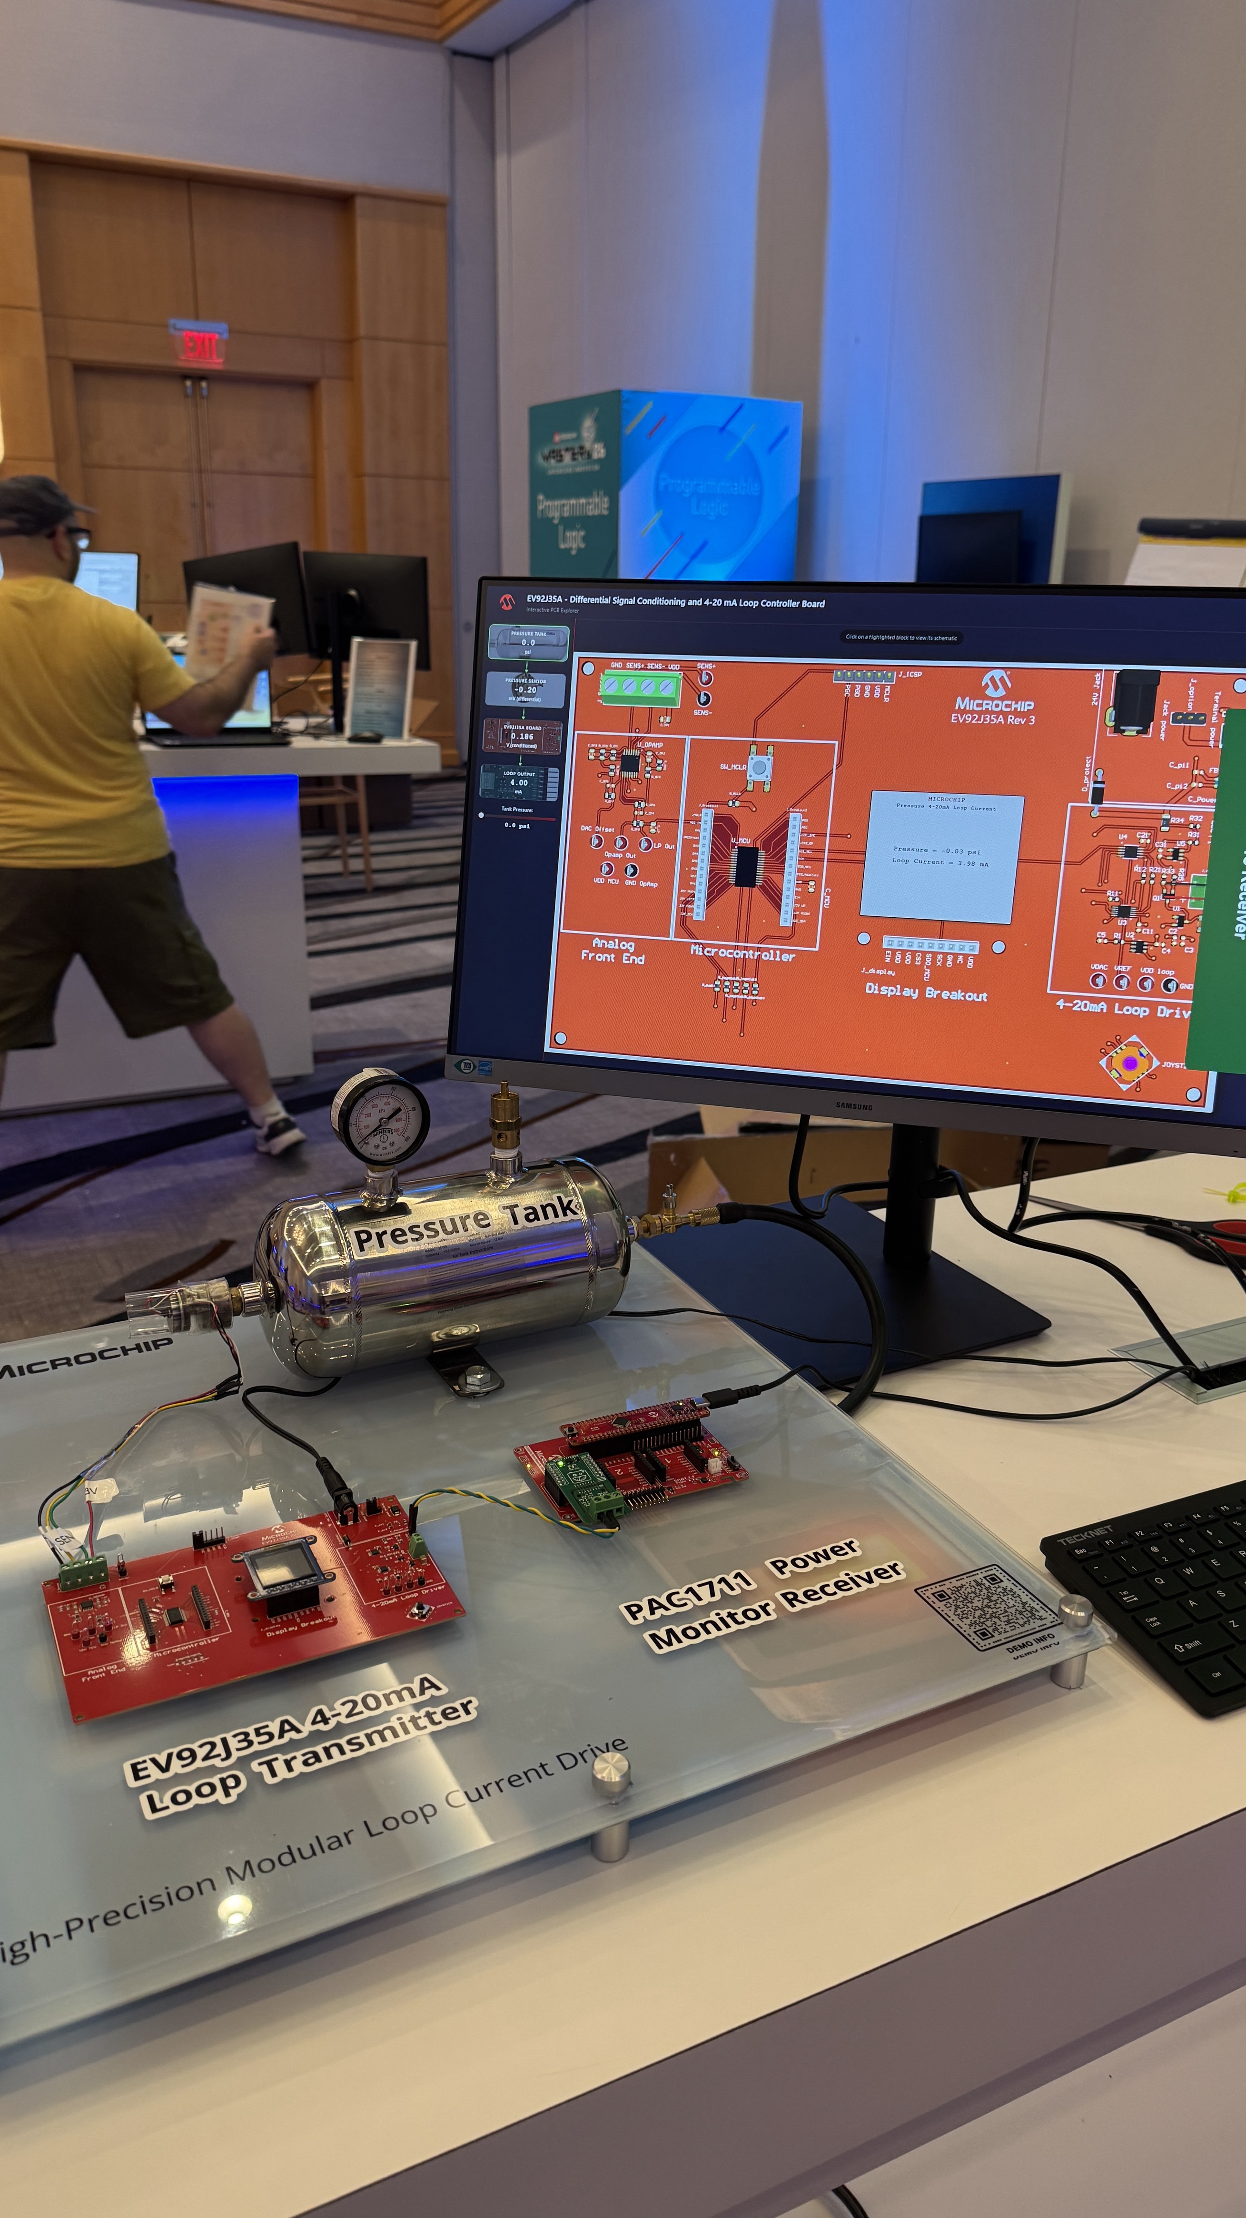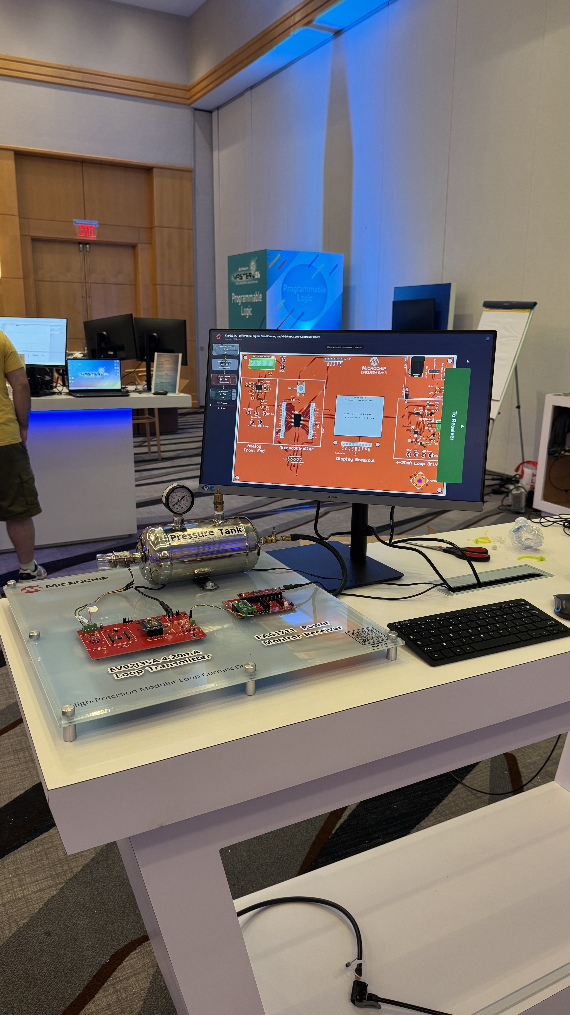

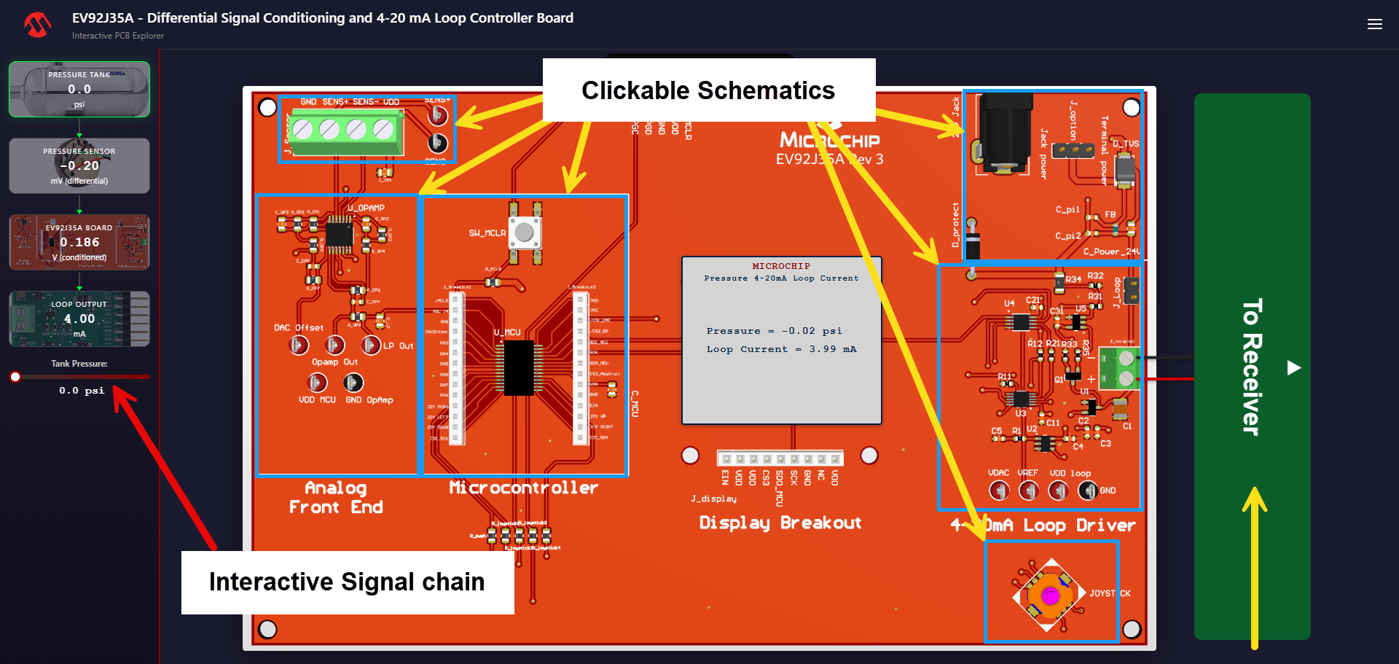
Demo GUI (.html file)
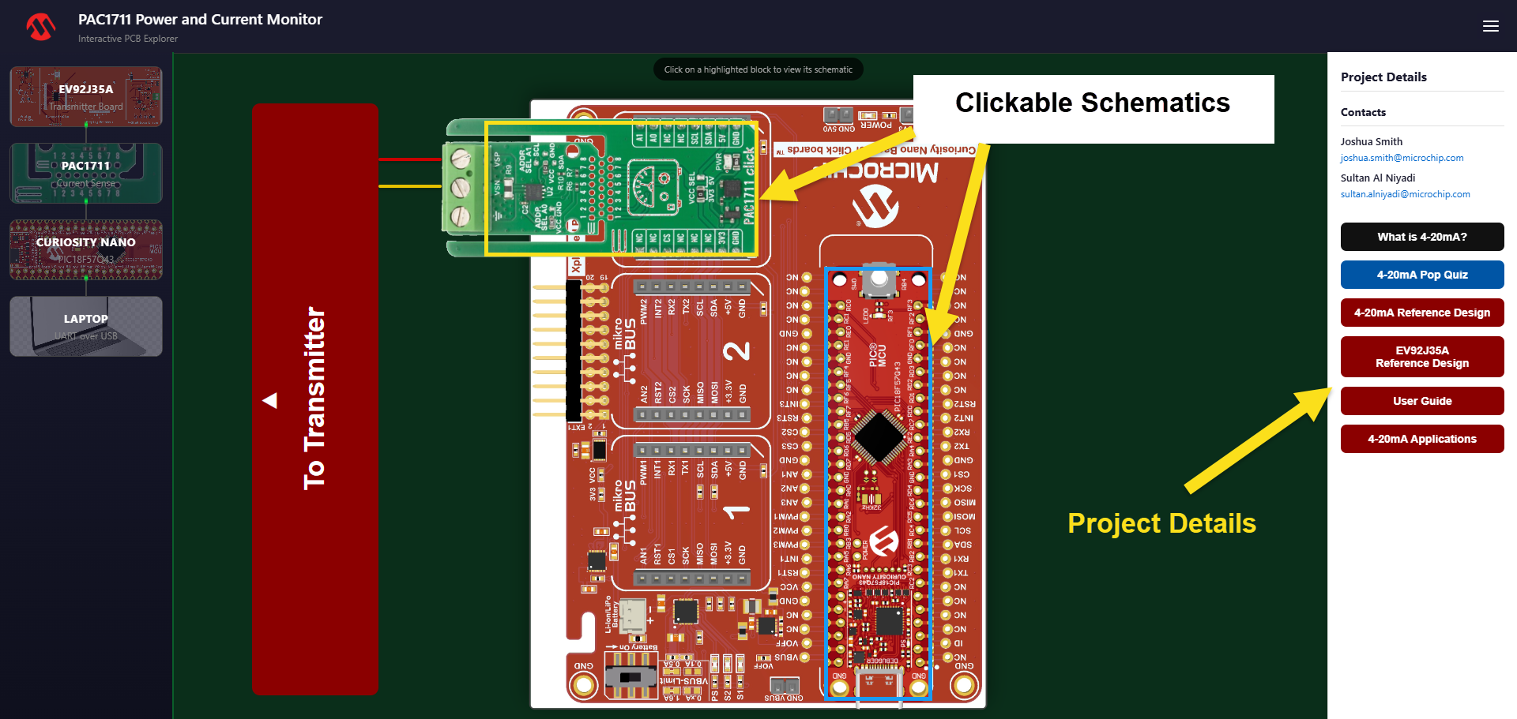

Running the Demo
EV92J35A Firmware
- Official demonstration firmware for the Microchip EV92J35A 4-20 mA pressure transmitter evaluation board. Reads a 0-50 PSI pressure sensor, converts the measurement to a 4-20 mA current loop signal per the NAMUR NE43 standard, and provides a live display with calibration and diagnostic tools.
Project Overview
- This firmware demonstrates a complete industrial 4-20 mA current loop transmitter implementation on a PIC18-class microcontroller. Key features:
- NAMUR NE43 compliant alarm signaling (3.6 mA under-range, 21.0 mA over-range) with hysteresis
- Constants-centric calibration system with NVM persistence across power cycles
- User-configurable measurement range (any pressure sub-range within the sensor span)
- Q16 fixed-point math throughout (no floating-point library, ~260 cycles per conversion at 1 MHz)
- Character-cell display driver using only ~278 bytes of RAM (no framebuffer)
Hardware Requirements
EV92J35A Evaluation Board
- A custom PCB integrating all required circuitry:
Subsystem | Key Components
Microcontroller | PIC18F26Q71 (64 KB flash, 4 KB RAM, 256 B EEPROM, 1 MHz HFINTOSC)
Analog Front End | MCP6V14 zero-drift instrumentation amplifier
Loop Driver | 4-20 mA current regulation circuit (based on EV34C35A reference design)
External DAC | MCP48CMD21 (12-bit, SPI)
Digital Potentiometer | MCP4152 (8-bit, SPI, sets loop current floor)
Power | On-board conditioning circuitry
Display Connector | Breakout for Adafruit SHARP Memory Display
External Components
Component | Description
Display | Adafruit 1.3" SHARP Memory Display (144x168 pixels, SPI)
Pressure Sensor | Strain Measurement Devices P571 (0-50 PSI, analog output)
Input | 5-button joystick (UP / DOWN / LEFT / RIGHT / PUSH)
Pin Assignments (PIC18F26Q71)
Pin | Function
RA0 | ADC input (pressure sensor via AFE)
RA2 | DAC1 output (AFE offset trim)
RB0 | CS - SHARP display
RB1 | SPI1 SDO (shared bus)
RB2 | SPI1 SCK (shared bus)
RB3 | SPI1 SDI (shared bus)
RB4 | CS - MCP4152 (loop driver digipot)
RB5 | CS - MCP48CMD21 (loop driver DAC)
RC0 | Joystick PUSH
RC1 | Joystick LEFT
RC2 | Joystick UP
RC5 | Joystick DOWN
RC6 | Joystick RIGHT
Usage Guide
On power-up, the Microchip logo displays for 3 seconds, then the system enters MONITOR mode. Press LEFT at any time in MONITOR to access the menu.
Menu Navigation
- UP / DOWN — scroll through menu items
- PUSH — select highlighted item
MONITOR (Normal Operation)
Displays live pressure (PSI) and loop current (mA). The system reads the pressure sensor, converts the reading to a 4-20 mA signal, and drives the current loop.
If the measured pressure goes outside the configured range:
- Below range: drives 3.6 mA and displays "LO ALARM"
- Above range: drives 21.0 mA and displays "HI ALARM"
Alarm thresholds include hysteresis to prevent display flicker near the boundaries.
RANGE SET (User Preference)
Defines which pressure values correspond to 4 mA and 20 mA. This is not calibration - it sets the user's desired measurement window within the sensor's physical range.
- The system forces the loop to 4 mA. Apply the desired low-end pressure to the sensor and press RIGHT to capture.
- The system forces the loop to 20 mA. Apply the desired high-end pressure and press RIGHT to capture.
- Review the captured values. Press RIGHT to apply, or LEFT to cancel.
Requires system calibration to be completed first (so the DAC codes for 4/20 mA are known).
CALIBRATE (System Calibration Wizard)
A 6-step guided procedure that characterizes the hardware. Requires an external current meter in the loop and a calibrated pressure source.
Step | Action | Equipment
1. AFE Offset | Apply 0 PSI to the sensor. Adjust the MCU-integrated DAC1 to null the amplifier offset. | None
2. Loop Floor | Adjust digipot until the loop reads ~3.6 mA (DAC held at 0). | Current meter
3. DAC at 4 mA | Adjust DAC code until meter reads exactly 4.000 mA. | Current meter
4. DAC at 20 mA | Adjust DAC code until meter reads exactly 20.000 mA. | Current meter
5. Sensor Low | Apply 0 PSI, press RIGHT to capture ADC reading. | Pressure source
6. Sensor High | Apply 50 PSI, press RIGHT to capture ADC reading. | Pressure source
After confirming, all values are stored to EEPROM and persist across power cycles.
Controls during calibration:
- UP / DOWN — adjust current parameter
- RIGHT — confirm step and advance
- LEFT — cancel entire calibration (restores all previous values)
MANUAL (DAC Evaluation)
Directly control the loop driver DAC output. Displays the DAC code and the corresponding computed current. Useful for:
- Comparing requested vs. actual loop current (with external meter)
- Evaluating DAC linearity
- Debugging calibration discrepancies
Controls: UP/DOWN to adjust DAC code, LEFT to return to menu.
DEMO (Triangle Wave Sweep)
Automatically sweeps the DAC output from 0 to 4095 and back in a triangle wave pattern (step size: 64 counts per tick). Displays the current DAC code and computed mA. Useful for observing the full output range on an oscilloscope or meter.
SPLASH (Logo Display)
Displays the Microchip logo for 3 seconds.
FACTORY RST (Factory Reset)
Invalidates the stored calibration in EEPROM and reinitializes the system with compile-time defaults. The next power cycle will behave as if the device has never been calibrated.

Setup Steps for PAC1711 GUI
Requirements
- Python 3.8+
- Windows 10/11 PC
- PIC18F57Q43 Curiosity Nano board (connected via USB)

Installation
1. Install Python
Check if Python is installed:
- python --version
If not installed, download from https://www.python.org/downloads/ and run the installer. Make sure to check "Add Python to PATH" during installation.

2. Copy Files
Copy these 6 items to a folder:
- pac1711_gui.py
- requirements.txt
- static/ (folder with 4 PNG images)

3. Install Dependencies
Navigate to your folder and run:
- pip install -r requirements.txt
This installs: PySide6, pyserial, pyqtgraph, numpy

4. Connect Hardware
Connect PIC18F57Q43 Curiosity Nano to PC via USB with PAC1711 placed in curiosity nano base board slot 3. Windows will install drivers automatically. Verify the device appears in Device Manager under "Ports (COM & LPT)".

5. Run GUI
python pac1711_gui.py
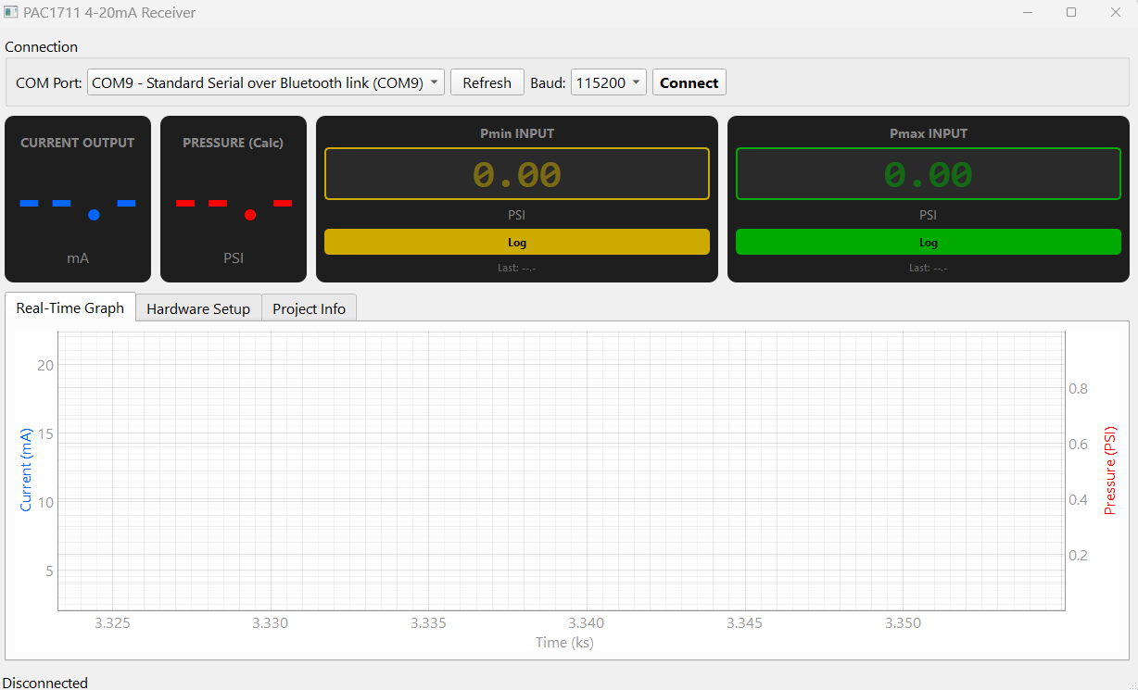This is how the GUI looks like when it's in a disconnected state. The window should open with three tabs: Real-Time Graph, Hardware Setup, and Project Info.

Using the GUI
1. Click the COM Port dropdown and select your device
2. Click "Refresh" if device is not listed
3. Select Baud rate: 115200
4. Click Connect button

Status bar will show "Connected" and current readings will appear.

Logging Pressure Values
**Pmin (Minimum Pressure):**
1. Set system to output 4 mA
2. Read pressure from external gauge
3. Enter value in Pmin field
4. Click Log or press Enter
**Pmax (Maximum Pressure):**
1. Set system to output 20 mA
2. Read pressure from external gauge
3. Enter value in Pmax field
4. Click Log or press Enter
Once both are logged, calculated pressure will display automatically.
GUI Display Fields:
Current Output: Live current reading (mA) from sensor
Pressure Calculated: Calculated pressure (PSI) based on Pmin/Pmax calibration
Pmin Input: Manual entry for minimum pressure reference
Pmax Input: Manual entry for maximum pressure reference

Graph: 30-second rolling view with four traces:
- Blue line: Current (automatic)
- Red line: Calculated pressure
- Orange line: Pmin value
- Cyan line: Pmax value
Calibration Formula
P = m·I + b
Where:
- m = (Pmax - Pmin) / 16 (Slope)
- b = Pmin - (m × 4) (Intercept)
- P = Pressure (PSI)
- I = Current (mA)

Input Validation
- Pmin must be >= 0
- Pmax must be <= 50
- Pmin must be < Pmax
- Pmax must be > Pmin

Layout

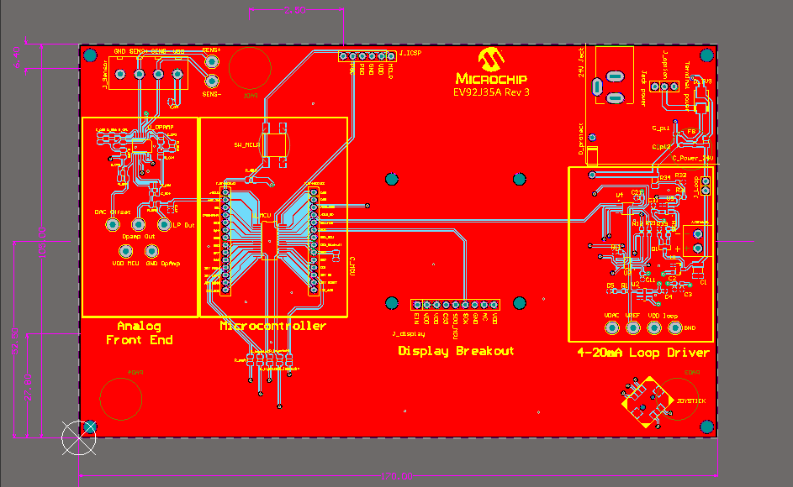
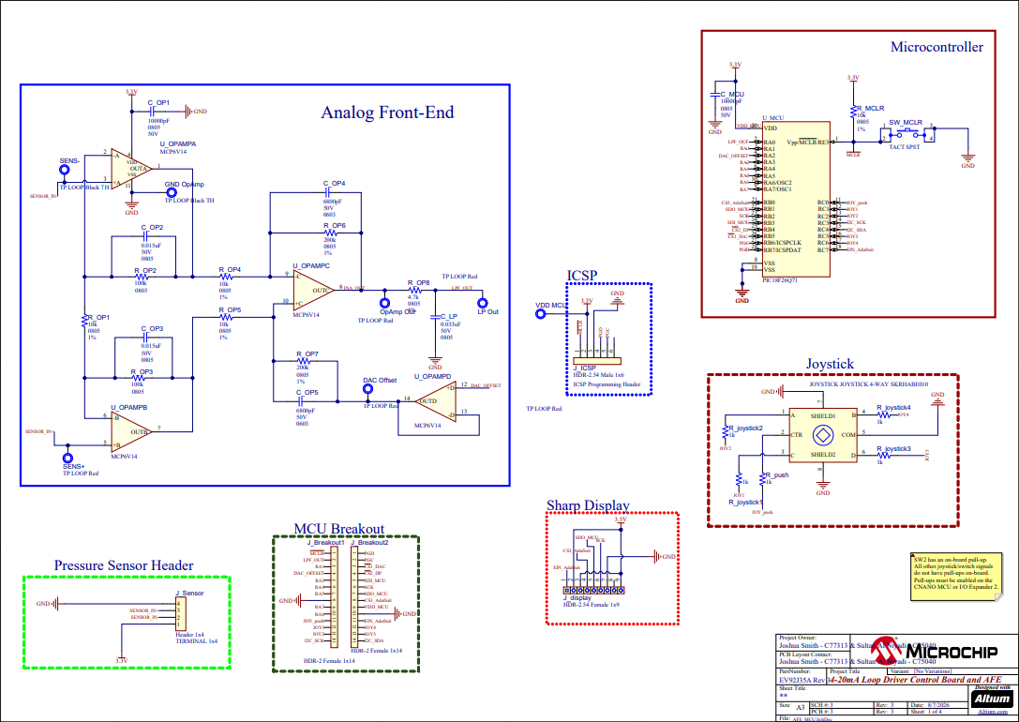
Schematic
